Year 10
OLNA class

End of Term 3 Test

2019


Name: ______________________ Class: ______ Time: 50 minutes Total Mark:____/48

Resources: No calculator allowed

Question 1 6 mark

Answer the following questions:
a) | 724.3 x 100 = | b) | 3.04 x 10 =
c) | 3.6 x 1000 = | d) | 4236 ÷1000 =
e) | 24 ÷ 100= | f) | 678 ÷ 10=

Question 2 1,2,1- 4 marks
Solve the following:
- 52 x 6 = b) 68 ×34 c) 4375 $÷5$

Question 3 1 mark
Josh offers Sam $\frac{3}{4}$ of his cake or $\frac{10}{16}$ of his cake. Which is a better offer? Explain your answer.

Question 4 2 mark

Convert 3 $\frac{5}{8}$ to an improper fraction

Convert $\frac{11}{4}$ to a mixed number

Question 5 1 marks
I am reading a comic which is 25 pages long. I have read 1/5 of it. How many pages have I read?

Question 6 2 marks
There is 60ml of cooldrink in my bottle, but I spill 2/3 of it – how much do have left to drink?

Question 7 1 mark
Billy made two types of cookies. He used ²/₃ cup of sugar for one recipe and ¹/₄ cup of sugar for the other. How much sugar (in cups) did he use in all?

Question 8 2 marks
Liam and Sam shared a chocolate bar. Liam ate ³/₅ and Sam ate ⁴/₁₀. Who ate more? How much more?

Question 9 1 mark
A running track is one kilometre long. If I jog for ¹/₆ km and run for ²/₃ km will I complete the full distance of the track?

Question 10 2 mark
A soldier drinks $\frac{2}{5}$ of a litre of water a day. How many litres will he need for 14 days?

Question 11 1,2- 3 mark
Solve the following:
- 35 – (17 – 2) ÷ 5 b) (8² – 2⁵) ÷ (24 ÷ 6) + 3²

Question 12 1 marks
A man wants to fit a new door. If the door frame is 2m 5cm high and the new door is 2.09m long, how much will he have to cut off the door?

Question 13 2 marks
The train was scheduled to arrive at 5:10 p.m. However, it was delayed for 25 minutes.
- What time was it when the train arrived?

- What is this time in 24hr time?

Question 14 2 marks
Kayla put cupcakes in the oven at 8:41 a.m. The directions say that the cupcakes need to bake for 38 minutes.
- What time will Kayla need to take them out of the oven?

- What is this time in 24hr time?

Question 15 4 marks
This is a train timetable from Norwich to Sheringham
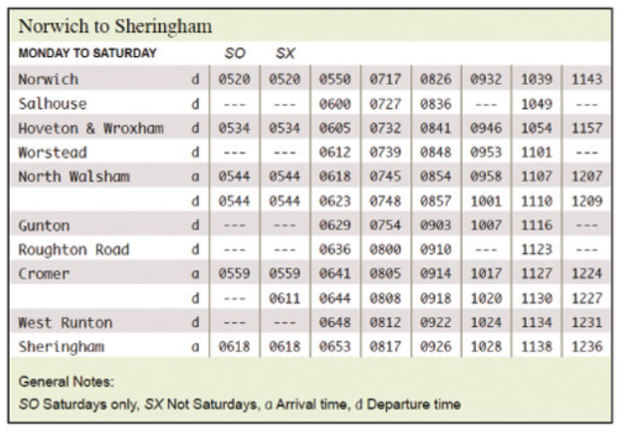
- What time does the 08.26 train from Norwich arrive at Cromer?

- Can I catch the 11.43 train from Norwich if I lived in Worstead?

- I want to be in Gunton by 7am. What train should I catch?

- How long is the journey from Norwich to North Walsham if I catch the 0717 train?

Question 16 2 marks
Tara can develop 2 rolls of film in about 18 minutes. At this rate, how long will it take her to develop 8 rolls of film?

Question 17 2 marks
Seth played his video game from 3:45pm until 5:10pm. He is only allowed to play video games for 80 minutes. Has he broken the rule?

Question 18 2 marks
Grace stayed at the beach for 32 days. Peter was there for 4 weeks and 6 days. Who was there longer and by how many days?

Question 19 2 marks
At a college, approximately 2 out of 5 seniors go on to attend graduate school. If there are 750 seniors at the college, how many would be expected to attend graduate school?

Question 20 2 marks
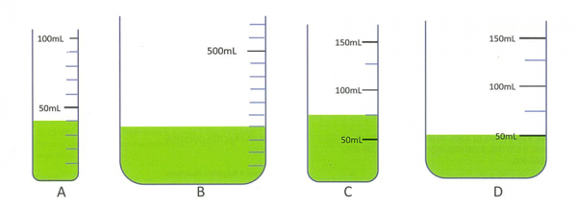

Which of the above containers has the most liquid?

Question 21 2 marks
Televisions are reduced by 10% in the sale.
A television costs $380 before the discount. How much does the television cost now it is on sale?

Question 22 1 marks
In a class of 40 students, 8 are in the drama club and 12 are in the art club. If a student is selected at random, what is the probability that the selected student is in the drama club?

Question 23 1 marks

Use the information below to answer the question that follows:
Monday | Tuesday | Wednesday | Thursday | Friday
7°C | 12°C | 4°C | – 13°C | – 15°C
As part of a unit on weather, students recorded the outdoor temperature at 8:30 A.M. for five mornings. What was the difference between the week's highest and lowest morning temperatures?

Question 24 2 marks

Lauren took 12 hours to read a 360 page book. At this rate, how long will it take her to read a 400 page book?

END OF TEST

